‘The Elephant in the Room’
Sexual Health Communications Toolkit 2026 (v17 28/04/2026)
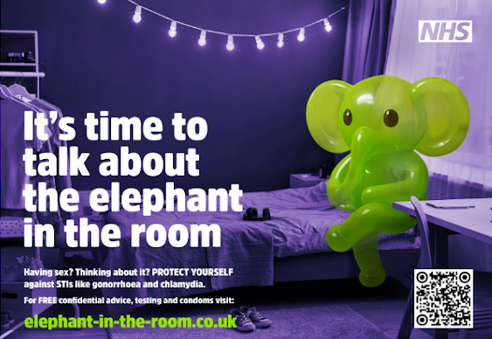
The Elephant in the Room
The NHS North East and North Cumbria Integrated Care Board (ICB), in partnership with UKHSA, OHID, Directors of Public Health and public health teams, across all our region's local authorities have developed the 'Elephant in the Room' campaign. Its aim is to raise awareness of sexually transmitted infections (STIs), promote confidential and FREE sexual health advice and services, and encourage safer sexual health behaviours among young people.
Background
The North East has some of the highest sexually transmitted infection (STI) rates in the country. STIs, especially in young people aged 15-24, have increased since 2019, with rates of gonorrhoea and chlamydia of particular concern.
The 'Elephant in the Room' campaign aims to reduce the stigma associated with sex and sexual health by encouraging honest conversations among young people, as well as increasing condom use and testing, to help reduce the transmission and harm from STIs.
The Elephant in the room digital toolkit is available for use and adaptation by all communication leads across the NHS, local authorities and other partners, to encourage uptake of STI testing, condom usage and general sexual health advice.

So, how can you help?
Information and content in the toolkit can be used on websites, social media, or other communication channels.

More content will be shared as we roll out the campaign. If there's something missing from the toolkit, or you would like something specific for your own organisation, channel, or simply have an idea of how we could better reach young people or share our messages, then please get in touch.

Your support in raising awareness of safe sex and sexual health is very much appreciated.

For further help or advice on using the toolkit or if you need support to tailor any assets, please contact: Andrea Jones, andrea.jones2@nhs.net or Anisah Sharmeen, anisah.sharmeen@nhs.net. If you work within a local authority, please contact your public health communications team.
Contents
- Campaign aim
- Key messages
- Target audience
- Ideas for localised promotion
- Download assets
- Newsletter copy (stakeholders and young people)
- Social media
- Videos
- Template press release

Campaign aim
To increase awareness and educate young people, aged 15-24, about STIs; promoting safe sex, including condom use, regular testing and how to access confidential sexual health services and information.

Key messages
- Your sexual health is just as important as your physical and mental health
- If you’re having sex, use condoms and get tested regularly for STIs
- Not all STIs show symptoms, so people may have an infection without knowing, meaning it can be passed on without realising and still cause serious long-term health problems
- Testing is quick, simple and confidential
- Condoms and STI testing are FREE to access, online and in person from local sexual health services
- There’s no judgement – sexual health services have heard it all before!

Who are we targeting?
- Young people – age 15 - 24
- Those who are sexually active, or are thinking about becoming sexually active

What young people told us (survey 15- 24yr-olds) - things to consider when you're using the campaign locally:
- Young people preferred messaging that was clear, direct and struck a balance between being engaging and professional.
- They would be uncomfortable interacting with sexual health content in highly visible public spaces, such as school corridors. By engaging, we mean things like scanning a QR code in a busy area, felt unrealistic to young people.
- They were more open to engaging with the content in private or semi-private settings, like toilet cubicles, changing rooms.
- They were comfortable seeing sexual health messaging in expected public spaces, such as interior bus panels, but were unlikely to interact with or act on it immediately while in public.
Advertising

The campaign will be supported by a limited three-month, paid-for, regional media advertising buy. This will have a multi-channel approach, including:
- Hyper-targeted paid social media (YouTube, TikTok, Instagram, Snapchat)
- Digital audio (Spotify, radio)
- Out of Home (OOH) and transport advertising
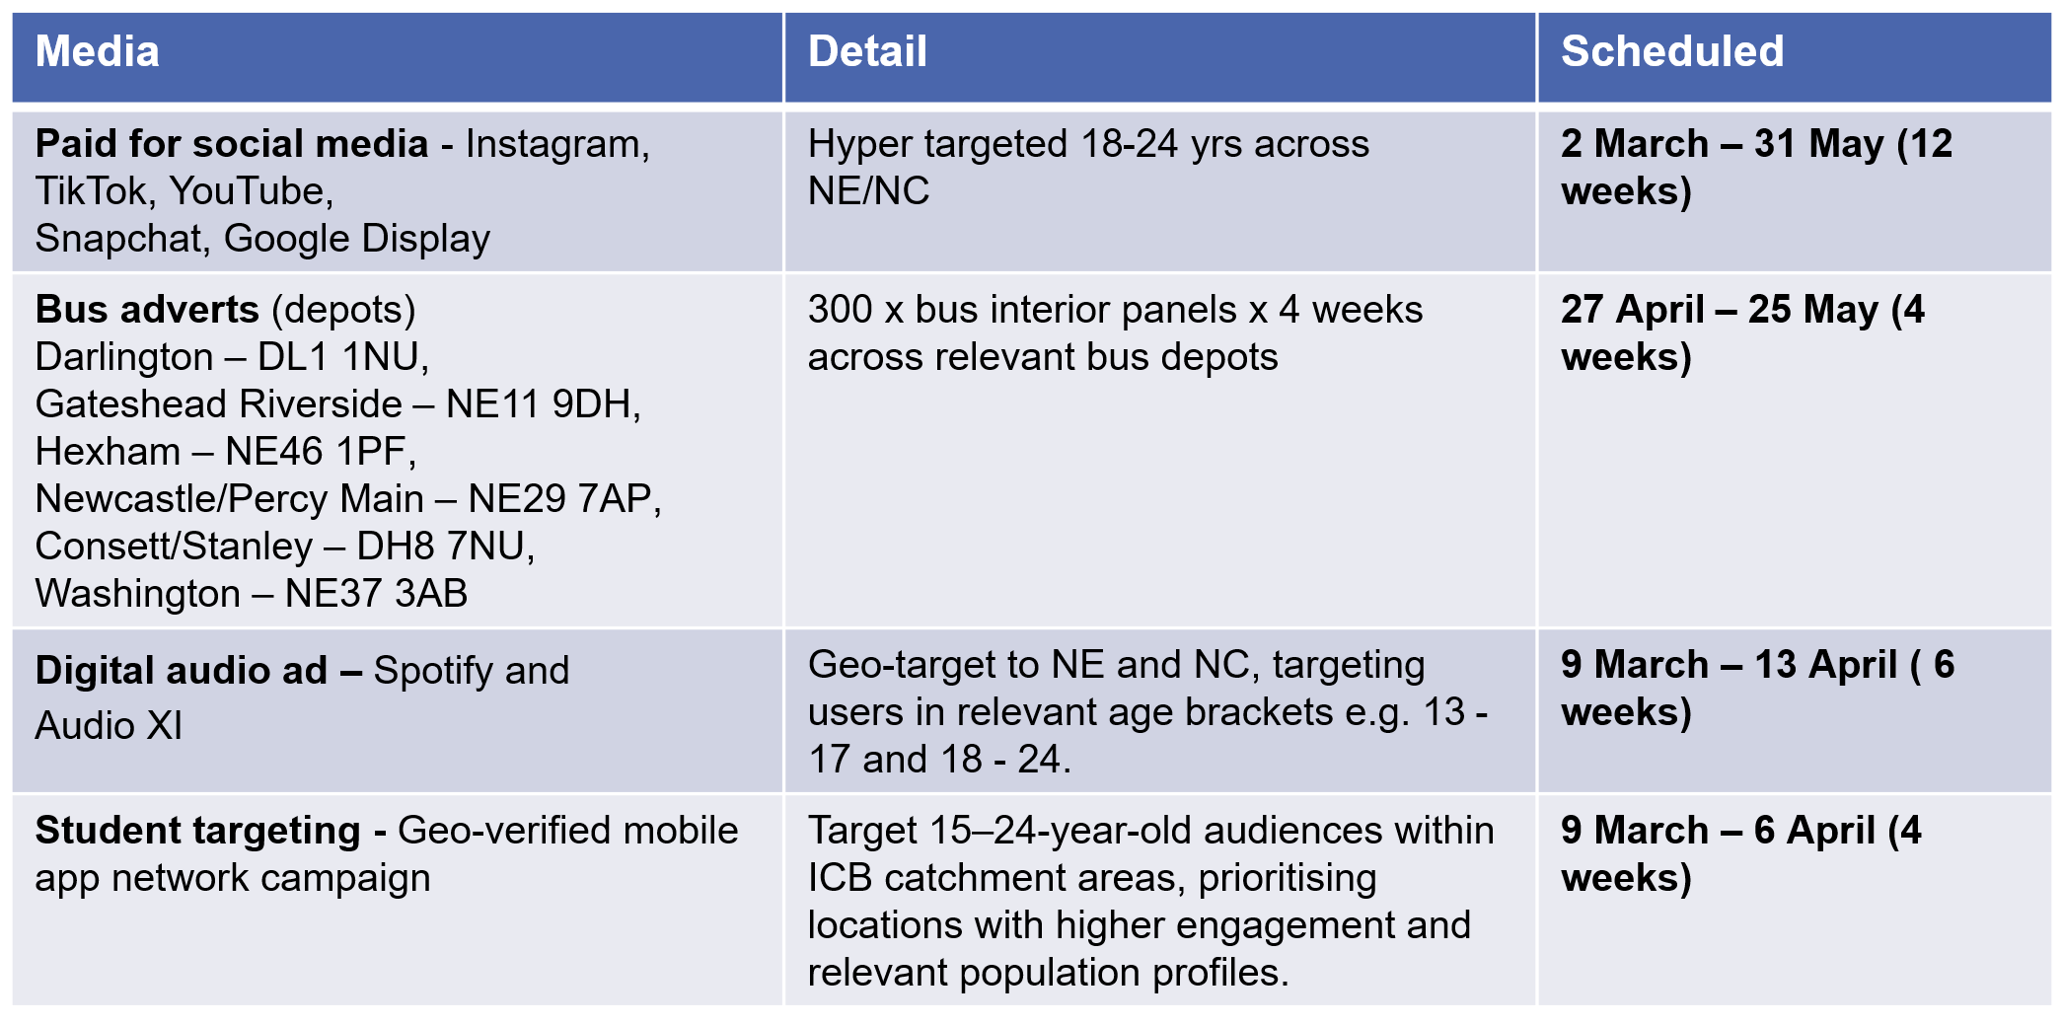
Regional paid for media buy details and schedule

Ideas for promoting the campaign in your area
Partner amplification across local authority, NHS and voluntary sector channels will be integral to the success of the campaign by linking with key stakeholders, including schools, colleges, universities, sexual health services and youth groups.
Insights from young people tell us:
- Messaging should be clear, direct and credible
- Interaction in highly visible public spaces is unlikely
- Private or semi-private spaces (toilets, changing rooms) are preferred
- Expected public spaces (e.g. buses) are acceptable for awareness, even if not immediate action
Here are some ideas to promote the campaign, but we appreciate that some of these will be based on the needs of your population, budgets and settings.
- Posters in toilets and private spaces, such as changing rooms in places used by young people such as schools, colleges and universities
- Pop-up stands in shopping centres/high footfall areas
- Youth events - posters
- Music venues - posters
- Sports and leisure facilities
- Drinks coasters in social venues
- Digital screens
- Websites
- Bus Adshels/carriage cards
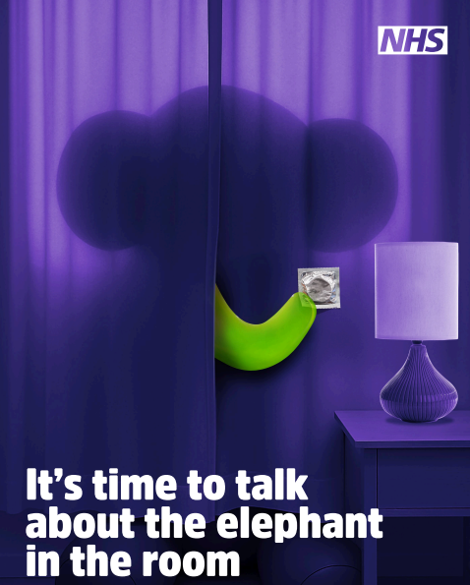
Download the campaign assets
All campaign assets for the Elephant in the Room sexual health campaign are available to download from the North East and North Cumbria Integrated Care Board (ICB) toolkit page.

Download here: Elephant in the room digital toolkit

We are asking colleagues and partners across the region to join us and help spread the word - it’s time to talk about the Elephant in the Room. By working together, we know that our messages are stronger and can reach many more of our communities, which means more people get tested, use protection and stop the spread of STIs.

Assets available in the toolkit:
- Pop-up stand design for shopping centres etc.
- Posters in varying sizes (with bleed)
- Drinks coaster design (for social venues)
- Digital screen designs
- Bus carriage card design (school buses)
- Web hero banner - various shapes/sizes
- Animations
- Videos
- Adshel/six sheet

Production of physical assets

Any production costs for the above assets from the toolkit (e.g. banners, posters, printed materials) will need to be covered locally. Central support is limited to the provision of artwork only.

Visit the Elephant in the Room campaign landing page

A dedicated campaign landing page has been created, which is hosted by the ICB, to signpost people to existing information about
  - Sexual health advice
  - Testing
  - Accessing free condoms
  - Contraception information

This includes educational, informative videos from frontline health professionals and young service users (embedded from ICB’s YouTube channel).

The page signposts to advice from Brook Advisory, NHS.UK and local sexual health services and condom distribution.

This will be the main call to action from all campaign materials – alongside messages about accessing FREE confidential advice, testing and condoms,

Visit the campaign landing page here – www.elephant-in-the-room.co.uk

Newsletter/website copy for stakeholders/partners
Let's get people talking – let's talk about the Elephant in the Room!
It’s time to stop avoiding the awkward stuff.

STI rates in our region are among the highest in the UK and more young people, aged 15 – 24, are being diagnosed with chlamydia and gonorrhoea.

But a new campaign is hoping to change that and get people talking.
The Elephant in the Room encourages young people to talk openly about sex, use condoms, get tested and access confidential sexual health services - no judgement. Just facts, support and better health.
The campaign's key messages include:
- If you’re having sex, protect yourself with condoms and regular testing
- Many STIs don’t show any symptoms, so people may have an infection without knowing, meaning it can be passed on without realising and still cause serious long-term health problems
- Testing is confidential and simple
- You’re not alone – support is available (and they’ve seen it all before!)
We’d love your help to spread the word. The more people we reach, the more we can support better sexual health across the region. Find out more at: www.elephant-in-the-room.co.uk

Download the 'Elephant in the Room' digital campaign toolkit here: Elephant in the room digital toolkit

The campaign toolkit is packed with ready-to-use content for websites, social media and other channels, which is easy to share and easy to use.

Got an idea? Noticed something missing? Want something tailored for your audience? We’d love to hear from you - contact Andrea Jones – andrea.jones2@nhs.net, or Anisah Sharmeen – anisah.sharmeen@nhs.net

Newsletter/website copy for young people
Having sex? Thinking about it?
Let’s talk about the elephant in the room - your sexual health!
Looking after your sexual health is just as important as your physical and mental health - but we get it… it can feel awkward to talk about.
Here’s the thing, some STIs, like chlamydia and gonorrhoea, don’t always show symptoms, which means they can be passed on without anyone knowing and still cause serious long-term health problems. That's why it's important to use condoms every time you have sex - it’s one of the best ways to protect yourself and others. We also recommend getting tested regularly - it’s free, quick, simple and confidential.
Want to know more? Visit www.elephant-in-the-room.co.uk to:
- Check where you can get free condoms
- Find your nearest STI testing clinic (or order an at-home test kit)
- Get clear, trusted sexual health advice from Brook
No judgement.
No embarrassment.
Just support, whenever you need it.

Social media

Please tag us in your social media posts - #ElephantInTheRoom

Facebook - NorthEastandNorthCumbriaNHS
X - @NENC_NHS
Instagram - nenc_nhs
TikTok - @nenc_icb
LinkedIn - @north-east-and-north-cumbria-nhs
YouTube - North East and North Cumbria NHS

We would recommend local amplification of the campaign on the following social media channels – please put all campaign links in the comments – some platforms reduce the reach of posts with external links, placing the link in the comments can help increase visibility.

- Instagram
- TikTok
- YouTube
- Snapchat
- Google Display

Elephant in the Room campaign | Social
Post | Instagram | Facebook | X | Visual/Film
Encouraging people to get tested - STIs | It's time to talk about the elephant in the room!  Having sex? Thinking about it?  PROTECT YOURSELF against STIs like chlamydia and gonorrhoea.  For FREE confidential advice, testing and condoms, visit:  elephant-in-the-room.co.uk  #ElephantInTheRoom | It's time to talk about the elephant in the room!  Having sex? Thinking about it?  PROTECT YOURSELF against STIs like chlamydia and gonorrhoea.  For FREE confidential advice, testing and condoms, visit:  www.elephant-in-the-room.co.uk  #ElephantInTheRoom | It's time to talk about the elephant in the room!  Having sex? Thinking about it?  PROTECT YOURSELF against STIs like chlamydia and gonorrhoea.  For FREE confidential advice, testing and condoms, visit:  www.elephant-in-the-room.co.uk  #ElephantInTheRoom | 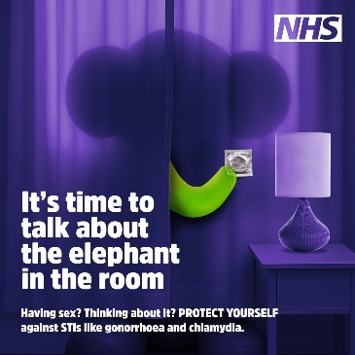  Put links in comments
Post | Instagram | Facebook | X | Visual/Film
Free condoms/testing | It's time to talk about the elephant in the room!  Yeah, we're talking safer sex!  PROTECT YOURSELF against STIs like chlamydia and gonorrhoea.  If you've had sex without a condom – GET TESTED  For free testing, condoms and confidential safe sex advice visit  elephant-in-the-room.co.uk  #ElephantInTheRoom | It's time to talk about the elephant in the room!  Yeah, we're talking safer sex!  PROTECT YOURSELF against STIs like chlamydia and gonorrhoea.  If you've had sex without a condom – GET TESTED  For free testing, condoms and confidential safe sex advice visit www.elephant-in-the-room.co.uk  #ElephantInTheRoom | It's time to talk about the elephant in the room!  Yeah, we're talking safer sex!  PROTECT YOURSELF against STIs like chlamydia and gonorrhoea.  If you've had sex without a condom – GET TESTED  For free testing, condoms and confidential safe sex advice visit www.elephant-in-the-room.co.uk  #ElephantInTheRoom | 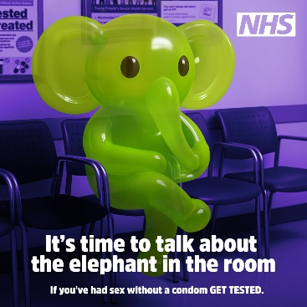  Put links in comments
Post | Instagram | Facebook | X | Visual/Film
Free confidential safe sex advice, testing and condoms | Having sex?  Thinking about having sex?  PROTECT YOURSELF against STIs like gonorrhoea and chlamydia.  For free confidential safe sex advice, testing and condoms visit elephant-in-the-room.co.uk  #ElephantInTheRoom | Having sex?  Thinking about having sex?  PROTECT YOURSELF against STIs like gonorrhoea and chlamydia.  For free confidential safe sex advice, testing and condoms visit www.elephant-in-the-room.co.uk  #ElephantInTheRoom | Having sex?  Thinking about having sex?  PROTECT YOURSELF against STIs like gonorrhoea and chlamydia.  For free confidential safe sex advice, testing and condoms visit www.elephant-in-the-room.co.uk  #ElephantInTheRoom | 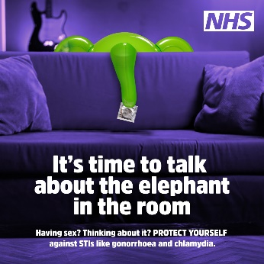  Put links in comments
Post | Instagram | Facebook | X | Visual/Film
Protect yourself | Having sex?  Protect yourself!  If you’re sexually active, use condoms and get tested regularly. Some STIs don’t show symptoms, so they can be passed on without you knowing and still cause serious long-term health problems.  The good news?  ✔ Free condoms  ✔ Free STI testing  ✔ Online testing available  ✔ Totally confidential  ✔ No judgement  Find free, confidential sexual health services at  elephant-in-the-room.co.uk  #ElephantInTheRoom | Having sex?  Protect yourself!  If you’re sexually active, use condoms and get tested regularly - some STIs don’t show symptoms, so they can be passed on without you knowing and still cause serious long-term health problems.  The good news?  ✔ Free condoms  ✔ Free STI testing  ✔ Online testing available  ✔ Totally confidential  ✔ No judgement  Find free, confidential sexual health services at  www.elephant-in-the-room.co.uk  #ElephantInTheRoom | Having sex?  Protect yourself!  Some STIs don’t have symptoms - so they can be passed on without you knowing.  Use condoms and get tested regularly.  For  ✔ Free condoms  ✔ Free STI testing  ✔ Online testing available  ✔ Confidential  ✔ No judgement  Visit www.elephant-in-the-room.co.uk  #ElephantInTheRoom | 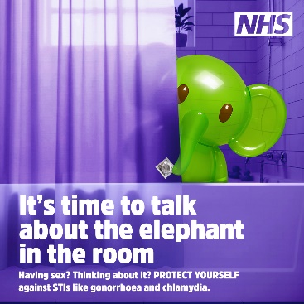  Put links in comments
Post | Instagram | Facebook | X | Visual/Film
Your sexual health matters just as much as your physical and mental health | Let’s talk about the elephant in the room!  Having sex? Thinking about having sex?  Your sexual health matters just as much as your physical and mental health - and it’s important to talk about it.  For free, confidential, safe sex advice, testing and condoms, visit www.elephant-in-the-room.co.uk  #ElephantInTheRoom | Let’s talk about the elephant in the room!  Having sex? Thinking about having sex?  Your sexual health matters just as much as your physical and mental health - and it’s important to talk about it.  For free, confidential, safe sex advice, testing and condoms visit www.elephant-in-the-room.co.uk  #ElephantInTheRoom | Let’s talk about the elephant in the room!  Having sex? Thinking about having sex?  Your sexual health matters just as much as your physical and mental health - and it’s important to talk about it.  For free, confidential, safe sex advice, testing and condoms visit www.elephant-in-the-room.co.uk  #ElephantInTheRoom | 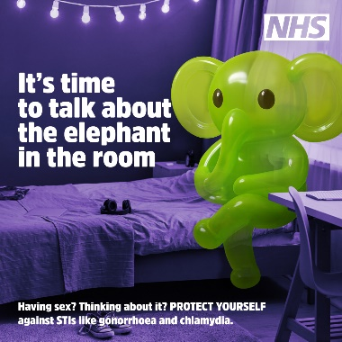  Put links in comments
Post | Instagram | Facebook | X | Visual/Film
Let’s keep talking about the elephant in the room. | Let’s keep talking about the elephant in the room.  Your sexual health!  Not all STIs have symptoms - but testing, including home testing, is quick, simple, confidential and FREE  Condoms are free too.  No judgement. No pressure. Just support.  Find free, confidential advice, testing and condoms at  elephant-in-the-room.co.uk  #ElephantInTheRoom | Let’s keep talking about the elephant in the room.  Your sexual health!  Not all STIs have symptoms - but testing, including home testing, is quick, simple, confidential and FREE.  Condoms are free too.  No judgement. No pressure. Just support.  Find free, confidential advice, testing and condoms at  www.elephant-in-the-room.co.uk  #ElephantInTheRoom | Let’s keep talking about the elephant in the room.  Your sexual health!  Not all STIs have symptoms - but testing, including home testing, is quick, simple, confidential and FREE.  Condoms are free too.  No judgement. No pressure. Just support.  Find free, confidential advice, testing and condoms at  www.elephant-in-the-room.co.uk  #ElephantInTheRoom | 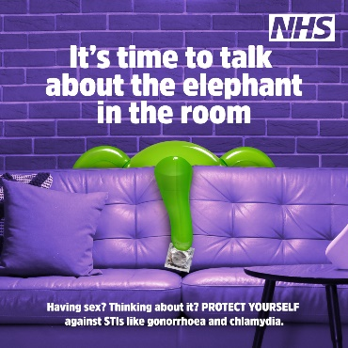  Put links in comments

Trusted voices videos
A series of short form videos that tackle the 'Elephant in the room', busting myths, stigma and awkwardness to deliver honest, helpful sexual health information and advice.

Our video stars are sexual health professionals, and young people, with real-life experience. Trusted, relatable voices sharing what matters.

Video star |  | Instagram | Facebook | X
Buddhika - Gen Z writes the marketing script  Video link: https://www.youtube.com/watch?v=IypoeNqSk5s&list=PLxLQTUPR0ago7G1NgcDFX7qBKNP1_ISus | 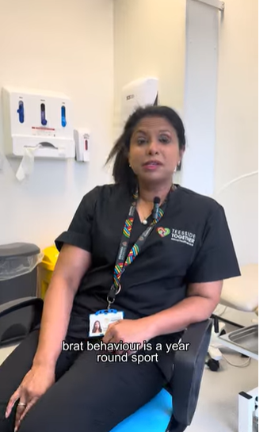 | We let the Gen Z colleague write the marketing script for our sexual health campaign.  The results? Iconic 💅  As Buddhika put it wisely: hot people get tested.  For FREE confidential advice, testing and condoms, visit 🔗 http://elephant-in-the-room.co.uk  #ElephantInTheRoom #SafeSex #WearCondoms #GetTested | We let the Gen Z colleague write the marketing script for our sexual health campaign.  The results? Iconic 💅  For FREE confidential advice, testing and condoms, visit 🔗 http://elephant-in-the-room.co.uk  #ElephantInTheRoom | We let the Gen Z colleague write the marketing script for our sexual health campaign.  The results? Iconic 💅  As Buddhika put it wisely: hot people get tested.  For FREE confidential advice, testing and condoms, visit 🔗 http://elephant-in-the-room.co.uk  #ElephantInTheRoom #SafeSex #WearCondoms #GetTested
Video star |  | Instagram | Facebook | X
Emily - Let’s talk about condoms - how to put a condom on correctly  Video link: https://www.youtube.com/watch?v=j86i2EvvIvE&list=PLxLQTUPR0ago7G1NgcDFX7qBKNP1_ISus&index=12 | 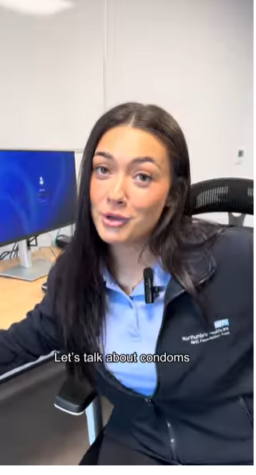 | Hear us out…how many of you know how to put a condom on correctly?  If you’re thinking about having sex, wearing a condom is crucial.  PROTECT yourself against STIs like chlamydia and gonorrhoea.  If you've had sex without a condom - GET TESTED  For free testing, condoms and confidential safe sex advice, visit 🔗 http://elephant-in-the-room.co.uk  #ElephantInTheRoom #SafeSex | Do you know how to put a condom on correctly?  PROTECT yourself against STIs like chlamydia and gonorrhoea.  For free testing, condoms and confidential safe sex advice, visit 🔗 http://elephant-in-the-room.co.uk  #ElephantInTheRoom #SafeSex | Hear us out…how many of you know how to put a condom on correctly?  If you’re thinking about having sex, wearing a condom is crucial.  PROTECT yourself against STIs like chlamydia and gonorrhoea.  If you've had sex without a condom - GET TESTED  For free testing, condoms and confidential safe sex advice, visit 🔗 http://elephant-in-the-room.co.uk  #ElephantInTheRoom #SafeSex
Video star |  | Instagram | Facebook | X
Steven - What you think a sexual health clinic is like vs what it’s actually like  Video link - https://www.youtube.com/watch?v=epEN_DTa1A0&list=PLxLQTUPR0ago7G1NgcDFX7qBKNP1_ISus&index=2 | 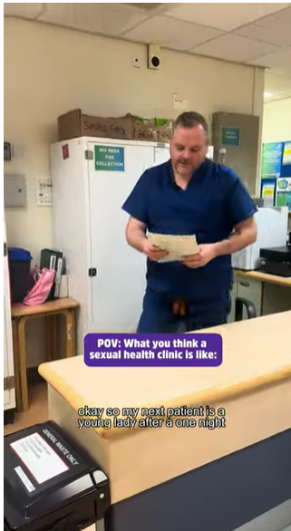 | POV: You thought a sexual health clinic would be scary.  Plot twist - it’s actually the opposite.  Sexual health nurses are here to support you and offer a non-judgemental, safe, confidential environment.  Don’t worry, they’ve heard it all before.  To find the nearest sexual health clinic, visit the Elephant in the Room website via the link in our bio 🔗  #ElephantInTheRoom #SafeSex #WearCondoms #GetTested | POV: You thought a sexual health clinic would be scary.  Plot twist - it’s actually the opposite.  Sexual health nurses are here to support you and offer a non-judgemental, safe, confidential environment.  Don’t worry, they’ve heard it all before.  To find the nearest sexual health clinic, visit 🔗 http://elephant-in-the-room.co.uk  #ElephantInTheRoom #SafeSex #WearCondoms #GetTested | POV: You thought a sexual health clinic would be scary, but it's actually the opposite.  Sexual health nurses are here to support you and offer a non-judgemental environment.  To find the nearest sexual health clinic, visit 🔗 http://elephant-in-the-room.co.uk  #ElephantInTheRoom
Video star |  | Instagram | Facebook | X
Sabrina - Let’s talk about the elephant in the room - introducing the campaign  Video link - https://www.youtube.com/watch?v=EfSQepMSj9Q&list=PLxLQTUPR0ago7G1NgcDFX7qBKNP1_ISus&index=18 | 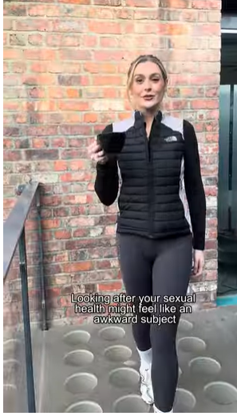 | Be honest…  When was the last time you had a conversation about your sexual health?  Whether you’re thinking about having sex, already doing it, or think you may have an infection, we’re here to help.  For FREE confidential advice, testing and condoms, visit the Elephant in the Room website via the link in our bio 🔗  #ElephantInTheRoom #SexualHealth | Be honest…  When was the last time you had a conversation about your sexual health?  Whether you’re thinking about having sex, already doing it, or think you may have an infection, we’re here to help.  For FREE confidential advice, testing and condoms, visit 🔗 http://elephant-in-the-room.co.uk  #ElephantInTheRoom #SexualHealth | Be honest…  When was the last time you had a conversation about your sexual health?  Whether you’re already having sex or thinking about doing it, visit 🔗 http://elephant-in-the-room.co.uk  #ElephantInTheRoom #SexualHealth
Video star |  | Instagram | Facebook | X
Sabrina - Put a finger down: s3xual health edition  Video link - https://www.youtube.com/watch?v=zp73BN0OI-4&list=PLxLQTUPR0ago7G1NgcDFX7qBKNP1_ISus&index=7 | 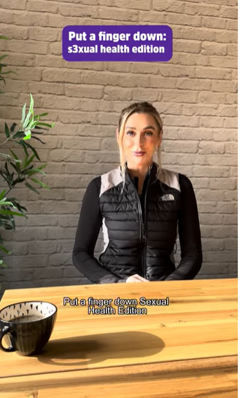 | Put a finger down, sexual health edition 👋  Talking about sex might feel embarrassing or awkward, but there’s nothing to be nervous about.  Your sexual health matters just as much as your physical health.  If you’re thinking about having sex or already doing it, GET TESTED.  For FREE confidential advice, testing and condoms, visit the Elephant in the Room website via the link in our bio 🔗  #ElephantInTheRoom #SafeSex #WearCondoms #GetTested | Put a finger down, sexual health edition 👋  Talking about sex might feel embarrassing or awkward, but there’s nothing to be nervous about.  Your sexual health matters just as much as your physical health.  If you’re thinking about having sex or already doing it, GET TESTED.  For FREE confidential advice, testing and condoms, visit 🔗 http://elephant-in-the-room.co.uk  #ElephantInTheRoom #SafeSex #WearCondoms #GetTested | Put a finger down, sexual health edition 👋  If you’re thinking about having sex or already doing it, GET TESTED.  For FREE confidential advice, testing and condoms, visit 🔗 http://elephant-in-the-room.co.uk  #ElephantInTheRoom #SafeSex #WearCondoms #GetTested
Video star |  | Instagram | Facebook | X
Sabrina - Four reasons to visit a sexual health clinic  Video link - https://www.youtube.com/watch?v=3J3L_0FeW4U&list=PLxLQTUPR0ago7G1NgcDFX7qBKNP1_ISus&index=8 | 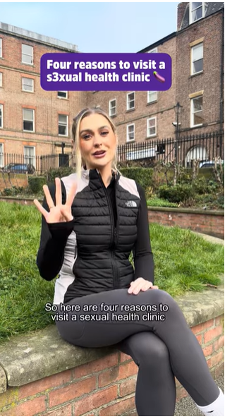 | When was the last time you visited a sexual health clinic?  Going to a clinic might feel scary, but there’s really nothing to worry about.  Whether you:  ✔️ Want testing after having unprotected sex  ✔️ You’ve noticed a change lately and would like some reassurance  ✔️ Need emergency contraception  And don’t worry, the nurses have seen it all before!  To find your nearest sexual health clinic, visit the Elephant in the Room website via the link in our bio  🔗  #ElephantInTheRoom #SafeSex #GetTested | When was the last time you visited a sexual health clinic?  Going to a clinic might feel scary, but there’s really nothing to worry about.  Whether you:  ✔️ Want testing after having unprotected sex  ✔️ You’ve noticed a change lately and would like some reassurance  ✔️ Need emergency contraception  And don’t worry, the nurses have seen it all before!  To find your nearest sexual health clinic, visit  🔗http://elephant-in-the-room.co.uk  #ElephantInTheRoom #SafeSex #GetTested | When was the last time you visited a sexual health clinic?  Whether you've noticed a change recently or would like some reassurance, the nurses are here to help.  To find your nearest sexual health clinic, visit  🔗http://elephant-in-the-room.co.uk  #ElephantInTheRoom
Video star | Script | Instagram | Facebook | X
Emily - Free condoms delivered to your house  Video link - https://www.youtube.com/watch?v=NfMyfjW7Lac&list=PLxLQTUPR0ago7G1NgcDFX7qBKNP1_ISus&index=5 | 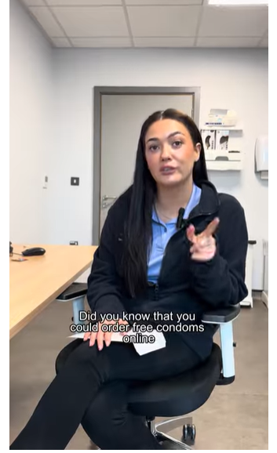 | Did someone say FREE condoms?  Whether you’re having sex or thinking about doing it, protect yourself against STs like chlamydia and gonorrhoea.  The good news is you can access FREE condoms at many sexual health clinics.  To find your nearest sexual health clinic, visit the Elephant in the Room website via the link in our bio 🔗  #ElephantInTheRoom #SafeSex #GetTested | Did someone say FREE condoms?  Whether you’re having sex or thinking about doing it, protect yourself against STs like chlamydia and gonorrhoea.  The good news is you can access FREE condoms at many sexual health clinics.  To find your nearest sexual health clinic, visit  🔗http://elephant-in-the-room.co.uk  #ElephantInTheRoom #SafeSex #GetTested | Did someone say FREE condoms?  Whether you’re having sex or thinking about doing it, protect yourself against STs like chlamydia and gonorrhoea.  To find your nearest sexual health clinic, visit  🔗http://elephant-in-the-room.co.uk  #ElephantInTheRoom #SafeSex #GetTested
Video star | Script | Instagram | Facebook | X
Buddhika - Gonorrhoea infection in under a minute  Video link - https://www.youtube.com/watch?v=6tMdKAS_N7o&list=PLxLQTUPR0ago7G1NgcDFX7qBKNP1_ISus&index=6 | 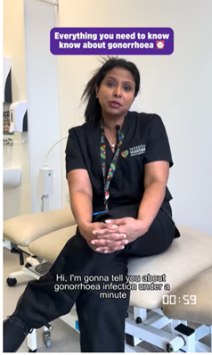 | Everything you need to know about gonorrhoea in under a minute.  Having sex?  PROTECT YOURSELF against STIs like gonorrhoea and chlamydia.  If you’ve had sex without using a condom - get tested!  For free testing, condoms and confidential advice, visit the Elephant in the Room website via the link in our bio 🔗  #ElephantInTheRoom #SafeSex #GetTested | Everything you need to know about gonorrhoea in under a minute.  Having sex?  PROTECT YOURSELF against STIs like gonorrhoea and chlamydia.  If you’ve had sex without using a condom - get tested!  For free testing, condoms and confidential advice, visit 🔗 http://elephant-in-the-room.co.uk  #ElephantInTheRoom #SafeSex #GetTested | Did someone say FREE condoms?  Whether you’re having sex or thinking about doing it, protect yourself against STs like chlamydia and gonorrhoea.  To find your nearest sexual health clinic, visit 🔗http://elephant-in-the-room.co.uk  #ElephantInTheRoom
Video star | Script | Instagram | Facebook | X
Steven Clay - Myths and Misconceptions  Video link - https://www.youtube.com/watch?v=kDc-uUTaTVc&list=PLxLQTUPR0ago7G1NgcDFX7qBKNP1_ISus&index=16 |  | Meet Steve, a sexual health nurse, who talks about some common myths about STIs.  This short video explains what STIs are, how people get them, and how to have safer sex.  #ElephantInTheRoom #SexualHealth #SafeSex #STIs | Meet Steve, a sexual health nurse, who talks about some common myths about STIs.  This short video explains what STIs are, how people get them, and how to have safer sex.  #ElephantInTheRoom #SexualHealth #SafeSex #STIs | Meet Steve, a sexual health nurse, who talks about some common myths about STIs.  This short video explains what STIs are, how people get them, and how to have safer sex.  #ElephantInTheRoom #SexualHealth #SafeSex #STIs
Video star | Script | Instagram | Facebook | X
Buddhika - What to expect from your sexual health appointment  Video link - https://www.youtube.com/watch?v=CQ4OIUWQVMA&list=PLxLQTUPR0ago7G1NgcDFX7qBKNP1_ISus&index=14 | 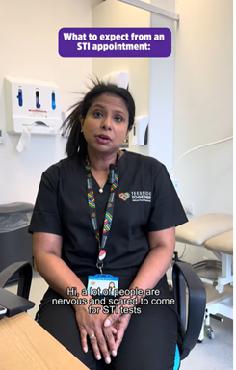 | Had unprotected sex but feel nervous about getting tested? Don’t worry, it’s totally normal.  Nurse Buddhika explains what to expect at a sexual health appointment, so you can feel more at ease and book a test.  #ElephantInTheRoom #SexualHealth #SafeSex #STIs | Had unprotected sex but feel nervous about getting tested? Don’t worry, it’s totally normal.  Nurse Buddhika explains what to expect at a sexual health appointment, so you can feel more at ease and book a test.  #ElephantInTheRoom #SexualHealth #SafeSex #STIs | Had unprotected sex but feel nervous about getting tested? Don’t worry, it’s totally normal.  Nurse Buddhika explains what to expect at a sexual health appointment, so you can feel more at ease and book a test.  #ElephantInTheRoom #SexualHealth #SafeSex #STIs
Video star | Script | Instagram | Facebook | X
Buddhika - Everything you need to know about Chlamydia  Video link - https://www.youtube.com/watch?v=ewLlpKanPXs&list=PLxLQTUPR0ago7G1NgcDFX7qBKNP1_ISus&index=12 | 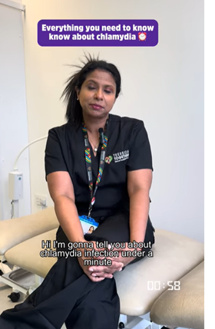 | Learn everything you need to know about the most common STI, chlamydia, in under one minute!  #ElephantInTheRoom #SexualHealth #SafeSex #STIs #Chlamydia | Learn everything you need to know about the most common STI, chlamydia, in under one minute!  #ElephantInTheRoom #SexualHealth #SafeSex #STIs #Chlamydia | Learn everything you need to know about the most common STI, chlamydia, in under one minute!  #ElephantInTheRoom #SexualHealth #SafeSex #STIs #Chlamydia
Video star | Script | Instagram | Facebook | X
Chloe - How to find your nearest sexual health clinic  Video link - https://www.youtube.com/watch?v=azL2mWPtS1g&list=PLxLQTUPR0ago7G1NgcDFX7qBKNP1_ISus&index=7 | 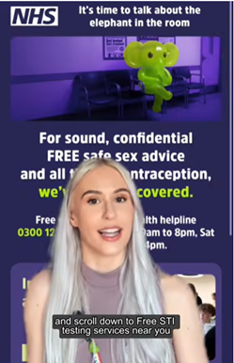 | Finding your nearest sexual health clinic just got even easier!  #ElephantInTheRoom #SexualHealth #SafeSex #STIs | Finding your nearest sexual health clinic just got even easier!  #ElephantInTheRoom #SexualHealth #SafeSex #STIs | Finding your nearest sexual health clinic just got even easier!  #ElephantInTheRoom #SexualHealth #SafeSex #STIs
Video star | Script | Instagram | Facebook | X
Chloe - Four reasons to visit the elephant in the room website  Video link - https://www.youtube.com/watch?v=OgiyMCJ0B78&list=PLxLQTUPR0ago7G1NgcDFX7qBKNP1_ISus&index=10 | 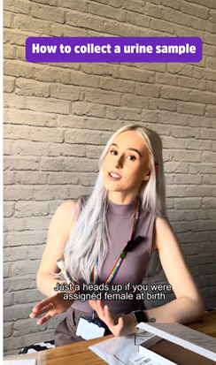 | If you haven’t visited our brand new website, maybe Chloe can persuade you 👀  #ElephantInTheRoom #SexualHealth #SafeSex #STIs | If you haven’t visited our brand new website, maybe Chloe can persuade you 👀  #ElephantInTheRoom #SexualHealth #SafeSex #STIs | If you haven’t visited our brand new website, maybe Chloe can persuade you 👀  #ElephantInTheRoom #SexualHealth #SafeSex #STIs
Video star | Script | Instagram | Facebook | X
Chloe Robson - Unboxing an at-home STI kit  Video link - https://www.youtube.com/watch?v=5G439rvF6-Q&list=PLxLQTUPR0ago7G1NgcDFX7qBKNP1_ISus&index=13 | 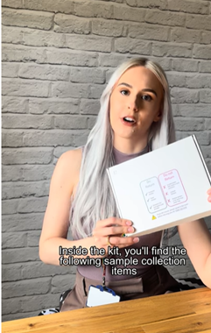 | In many cases, you can order an STI test kit straight to your home. It’s discreet, quick, and easy to use.  Visit the Elephant in the Room website to find out more.  #ElephantInTheRoom #SexualHealth SafeSex #STIs | In many cases, you can order an STI test kit straight to your home. It’s discreet, quick, and easy to use.  Visit the Elephant in the Room website to find out more.  #ElephantInTheRoom #SexualHealth #SafeSex #STIs | In many cases, you can order an STI test kit straight to your home. It’s discreet, quick, and easy to use.  Visit the Elephant in the Room website to find out more.  #ElephantInTheRoom #SexualHealth #SafeSex #STIs
Video star | Script | Instagram | Facebook | X
Chloe - How to collect a swab sample  Video link - https://www.youtube.com/watch?v=fWMWPBOotMo&list=PLxLQTUPR0ago7G1NgcDFX7qBKNP1_ISus&index=11 | 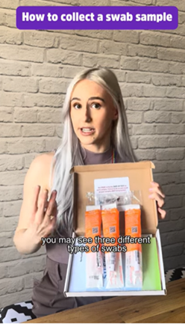 | If you’ve ordered an at-home STI test kit and need to take a swab, this video shows you exactly how 🤳  #ElephantInTheRoom #SexualHealth #SafeSex #STIs | If you’ve ordered an at-home STI test kit and need to take a swab, this video shows you exactly how 🤳  #ElephantInTheRoom #SexualHealth #SafeSex #STIs | If you’ve ordered an at-home STI test kit and need to take a swab, this video shows you exactly how 🤳  #ElephantInTheRoom #SexualHealth #SafeSex #STIs
Video star | Script | Instagram | Facebook | X
Chloe - How to collect a urine sample  Video link - https://www.youtube.com/watch?v=6U30VXwXKIs&list=PLxLQTUPR0ago7G1NgcDFX7qBKNP1_ISus&index=15 | 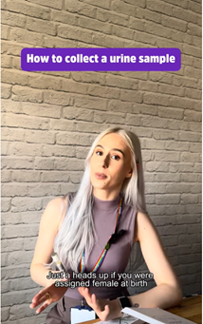 | If you’ve ordered an at-home STI test kit you may need to provide a urine sample. This video shows you exactly how 🤳  #ElephantInTheRoom #SexualHealth #SafeSex #STIs | If you’ve ordered an at-home STI test kit you may need to provide a urine sample. This video shows you exactly how 🤳  #ElephantInTheRoom #SexualHealth #SafeSex #STIs | If you’ve ordered an at-home STI test kit you may need to provide a urine sample. This video shows you exactly how 🤳  #ElephantInTheRoom #SexualHealth #SafeSex #STIs

Do you know someone who could be a video star trusted voice?
Email Anisah Sharmeen Anisah.sharmeen@nhs.net or Andrea Jones andrea.jones2@nhs.net with their details.
Press release

Let's Talk About 'The Elephant in the Room' - Safer Sex
Campaign launched to tackle Sexually Transmitted Infection (STI) rates in the region
NHS data reveals North East has some of the highest rates of STIs in the country, with under-25s most affected.
2024 UK Health Security Agency (UKSHA) data shows:
- The North East has the third highest rates of sexually transmitted infections in the UK (with London in first place and the North West in second).
- There were 14,847 new STIs diagnosed in North East residents, a rate of 548 diagnoses per 100,000 population.
- Those aged between 15 and 24 years accounted for 50 percent of all new STI diagnoses.
- Chlamydia remains the leading STI, making up over half of all new cases and two-thirds of diagnoses among young people.

A new campaign has been launched to help reduce rates of sexually transmitted infections (STIs) by starting a conversation that many people find difficult to talk about - their sexual health.
Chlamydia remains the leading STI, making up over half of all new cases and two-thirds of diagnoses among young people. While gonorrhoea cases went down in some local authority areas in 2024, numbers are still much higher than before the COVID-19 pandemic.
Many STIs don’t show signs or symptoms but can still cause serious health problems. This means someone might have an infection without knowing it and could pass it on without realising.
The 'Elephant in the Room' campaign uses bold creative imagery and youth-focused digital content. Its message is simple: testing is normal, protection matters, and talking about sex shouldn’t be awkward.
The campaign encourages regular testing, using condoms during sex to protect against STIs, and signposts to free, confidential safe sex advice and support.
Dr Alex Kent, medical director, NHS North East and North Cumbria Integrated Care Board (ICB), said: "Sexual health is an important part of overall health, but many people still feel embarrassed talking about it.
"The elephant in the room campaign is about opening up conversations and helping young people see sexual health check-ups as just another normal part of taking care of themselves.
"Getting tested, using protection and asking questions are normal and responsible things to do, and, if you’re sexually active, regular testing helps protect both you and your partners.
"Sexual health services are completely confidential, with expert teams who are friendly, experienced and always respectful. Whether someone walks into a clinic, contacts them online or picks up the phone, they will be treated with understanding and care."
Lorraine Hughes, director of public health, Darlington Borough Council, and regional lead for sexual health, added: "STI rates among young people are a real concern across our region.
"By talking about sexual health openly, we hope many more young people will feel confident to get tested, access free condoms and use the support that’s available."
The elephant in the room campaign directs young people to a dedicated website with clear advice, trusted information and links to local sexual health services.
-Ends-
For more information, visit: www.elephant-in-the-room.co.uk
Notes to editor
More UKSHA data can be found here.
The NHS North East and North Cumbria Integrated Care Board (ICB), in partnership with UKHSA, OHID, Directors of Public Health, and public health teams, across all our region's local authorities have developed the 'Elephant in the Room' campaign.

