Internal social media toolkit for the Staff Mental Health and Wellbeing Hub
This social media toolkit has been created to help NHS organisations promote a new Staff Mental Health and Wellbeing Hub the across their internal channels. This video was produced with Dr Richard Duggins, consultant psychiatrist at CNTW.
The Hub offers free, confidential and timely help for health and social care staff across the North East and North Cumbria, including support for stress, burnout, anxiety, low mood and other challenges that can affect wellbeing at work and at home. You can find out more about the Hub here.
The Hub has recently received some additional funding as part of the region's Work Well programme which is about supporting people – including our staff – to stay well and working. The extra funding is being used to enable more staff to access this important service and to expanding its offer of specialist support for things like addiction, menopause and much more. More information will be provided on support offers as they become live.
Copy | Media
“We really encourage staff to use us at the first point when they're worried about stress or burnout or perhaps anxiety or depression. Come and see us early because we can then nip it in the bud." Dr Richard Duggins  If you’re feeling stressed, burnt out, anxious or low, the Staff Mental Health and Wellbeing Hub offers free, confidential support for all health and social care staff across the North East and North Cumbria.  Support is quick to access and designed to help before problems grow.  👉 Find out more:  https://northeastnorthcumbria.nhs.uk/here-to-help-you/health-advice-and-support/staff-wellbeing-hub/ | 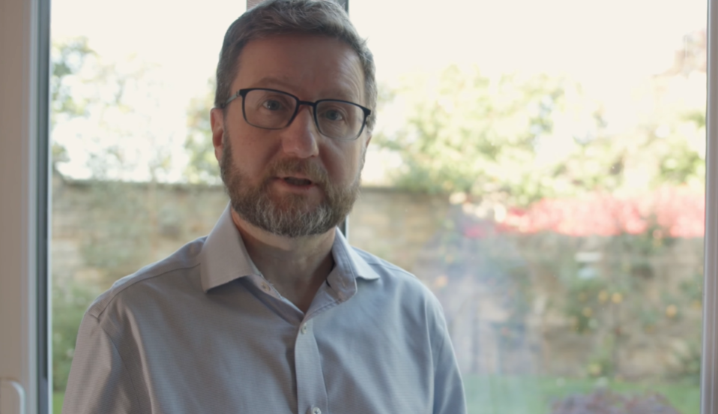  Link to film: https://www.youtube.com/watch?v=-OYbufRdjGE  Download here: https://northeastnorthcumbria.nhs.uk/toolkits/staff-wellbeing-hub-toolkit/
“We’ll see you quickly, take time to understand what’s going on, and plan a way forward together.” Dr Richard Duggins  The Staff Mental Health and Wellbeing Hub offers confidential support, usually with contact returned the same day and appointments within a week.  Whether you need a brief conversation, therapy or more specialist help, support is tailored to you.  👉 Access the Hub:  https://northeastnorthcumbria.nhs.uk/here-to-help-you/health-advice-and-support/staff-wellbeing-hub/ | Link to film: https://www.youtube.com/watch?v=-OYbufRdjGE  Download here: https://northeastnorthcumbria.nhs.uk/toolkits/staff-wellbeing-hub-toolkit/
“Coming to us early makes it less likely to affect your work and helps you stay well doing the job you care about.” Dr Richard Duggins  The Hub offers specialist support for:  • Stress, burnout, anxiety and depression  • Menopause  • Alcohol or substance use concerns  All support is free and confidential for health and social care staff in the North East and North Cumbria.  👉 Get support here:  https://northeastnorthcumbria.nhs.uk/here-to-help-you/health-advice-and-support/staff-wellbeing-hub/ | Link to film: https://www.youtube.com/watch?v=-OYbufRdjGE  Download here: https://northeastnorthcumbria.nhs.uk/toolkits/staff-wellbeing-hub-toolkit/

